

**HERITAGE GLOBAL ACADEMY**

2, Ola Iya close, Off Okiki Street, Isawo Road, Owutu Agric-Ikorodu, Lagos

**SECOND TERM CA2 2023/2024 SESSION**

**Subject: CHECKPOINT PHYSICS**

**Class: JSS3 Time: 50 Minutes**

INSTRUCTION: **Answer all questions.**

1. Selenium-83 has a half-life of 25.0 minutes. How many minutes would it take for a 10.0 mg sample to decay and only have 1.25 mg of it remain? (3 marks)
2. How long does it take a 100g sample of As-81, with a half-life of 33 seconds, to decay to 6.25g?

(3 marks)

1. An unknown element X of mass number 546 and atomic number 100 disintegrates with single alpha and beta emission. Let the new element formed be Y, what will be its mass number and atomic number? (4 marks)
2. Draw a line from each ***method of energy transfer*** to its ***example.*** (4 marks)

**Method of Energy Transfer Example**

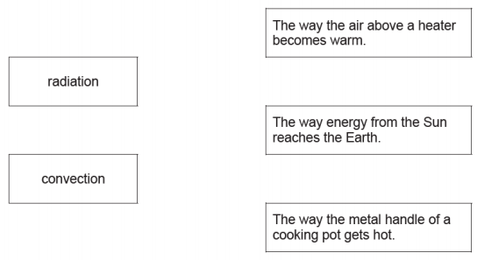

1. Complete the sentences about thermal (heat) energy transfer.

Choose words from the list.

[**Conduction Convection Radiation**]

Thermal (heat) energy can be transferred from one place to another.

1. When particles are involved, the processes are_____________and __________. (2 marks)
2. When electromagnetic waves are involved, the process is _________________. (2 marks)
3. The diagram shows how a room can be heated. The arrows show the direction of air movement.

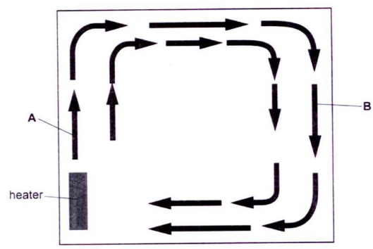

Use the diagram to complete the sentences.

At A, warm air rises because it is ___________ dense. (2 marks)

At B, cool air sinks because it is ____________ dense. (2 marks)

The arrows moving in a clockwise manner can also be referred to as _____________current. (2 marks)

1. Redraw the set up below and draw a line from the **type of energy** to its **description** and **example.**

**One has been done for you** (8 marks)

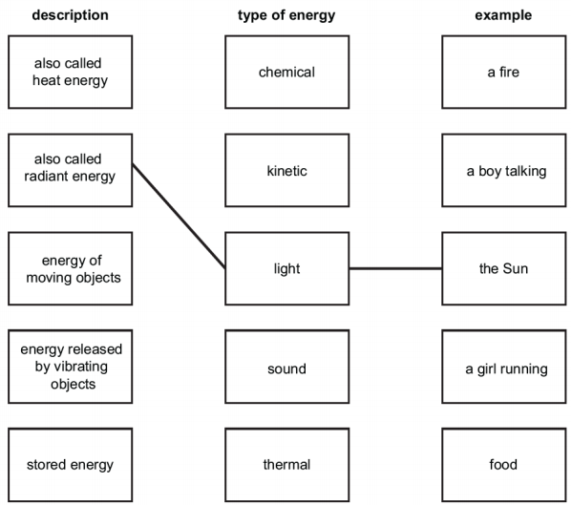

1. Rayhaan investigates heat transfer. He heats a metal rod. The metal rod has a pin attached with wax.

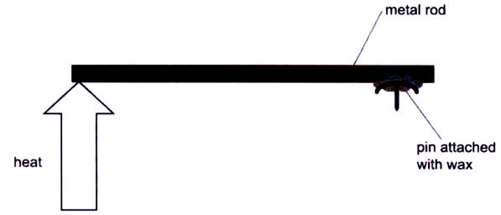

When the end of the metal rod is hot, the wax melts and the pin falls.

1. What type of heat transfer is Rayhaan investigating? (2 marks)
2. Rayhaan repeats the investigation with rods made of different metals. The pins fall after different amount of time. Why do the pins fall after different amount of time? (4 marks)
3. In which decay is the Helium nucleus emitted? (2 marks)